Run the docker Compose file below to stand up your Postgres database and the PgAdmin tool

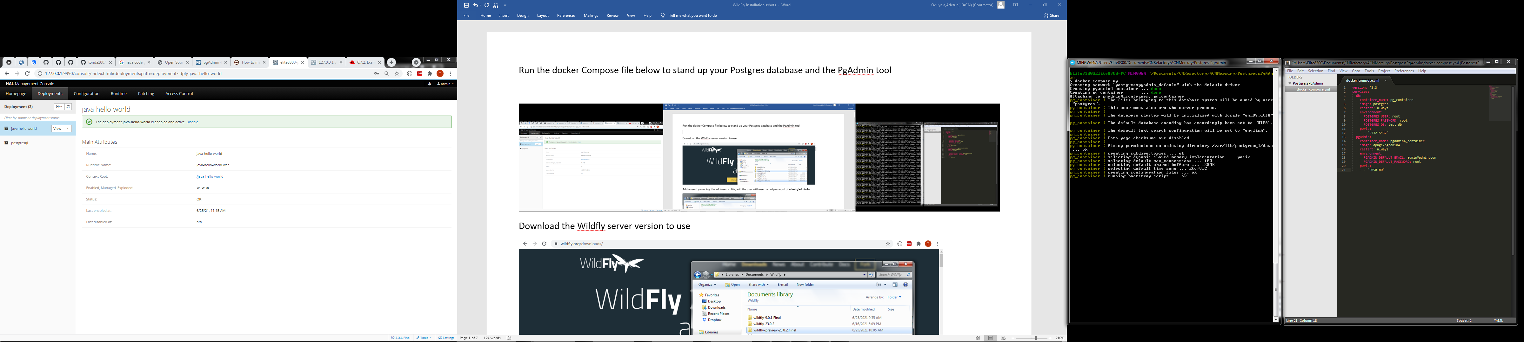

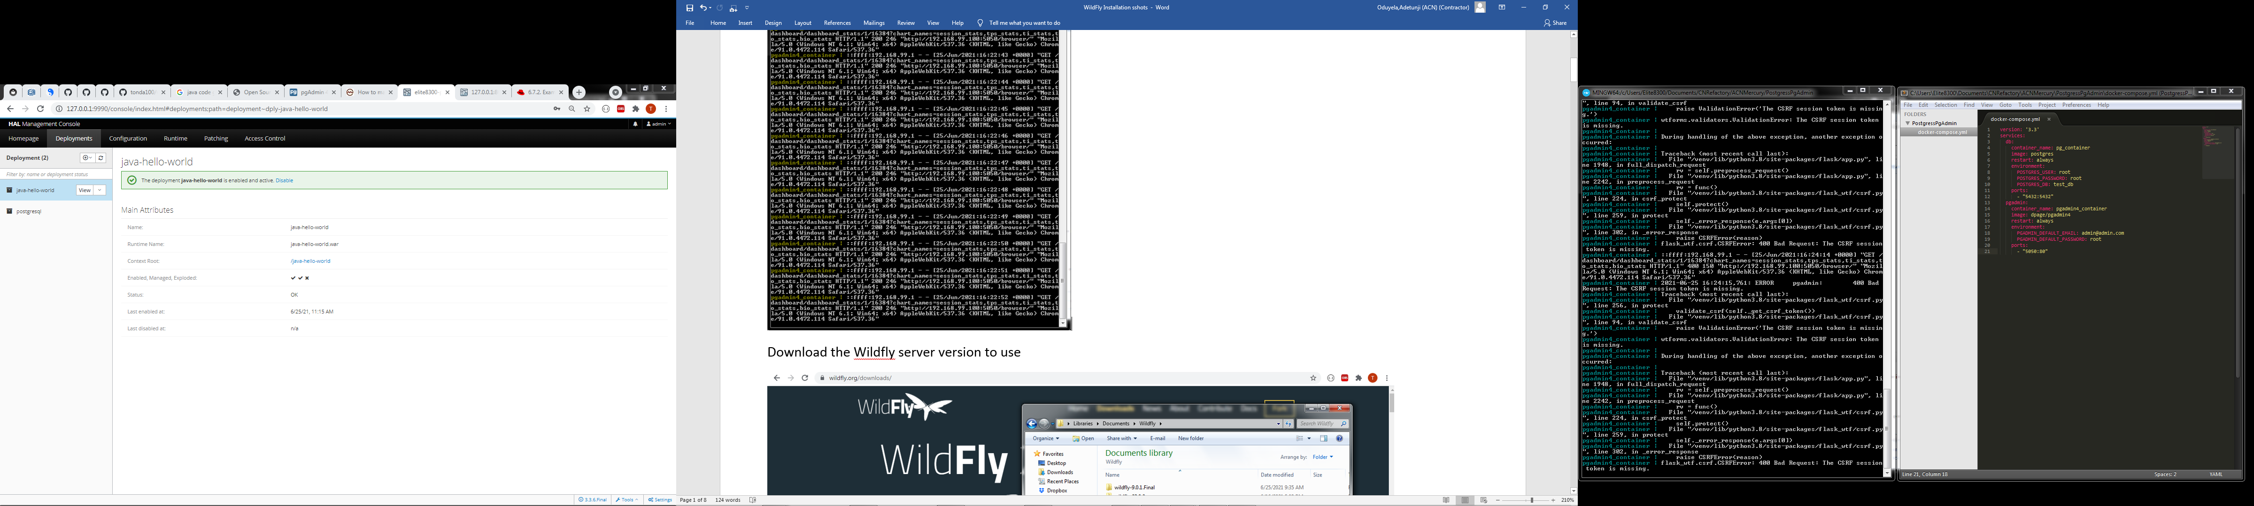 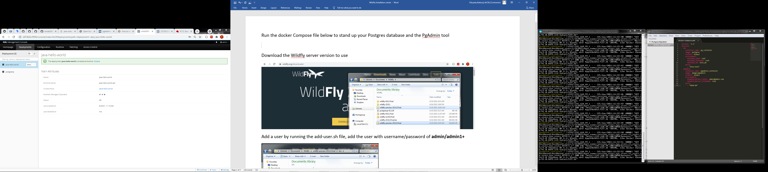

Log into the PgAdmin tool and connect to Postgres database

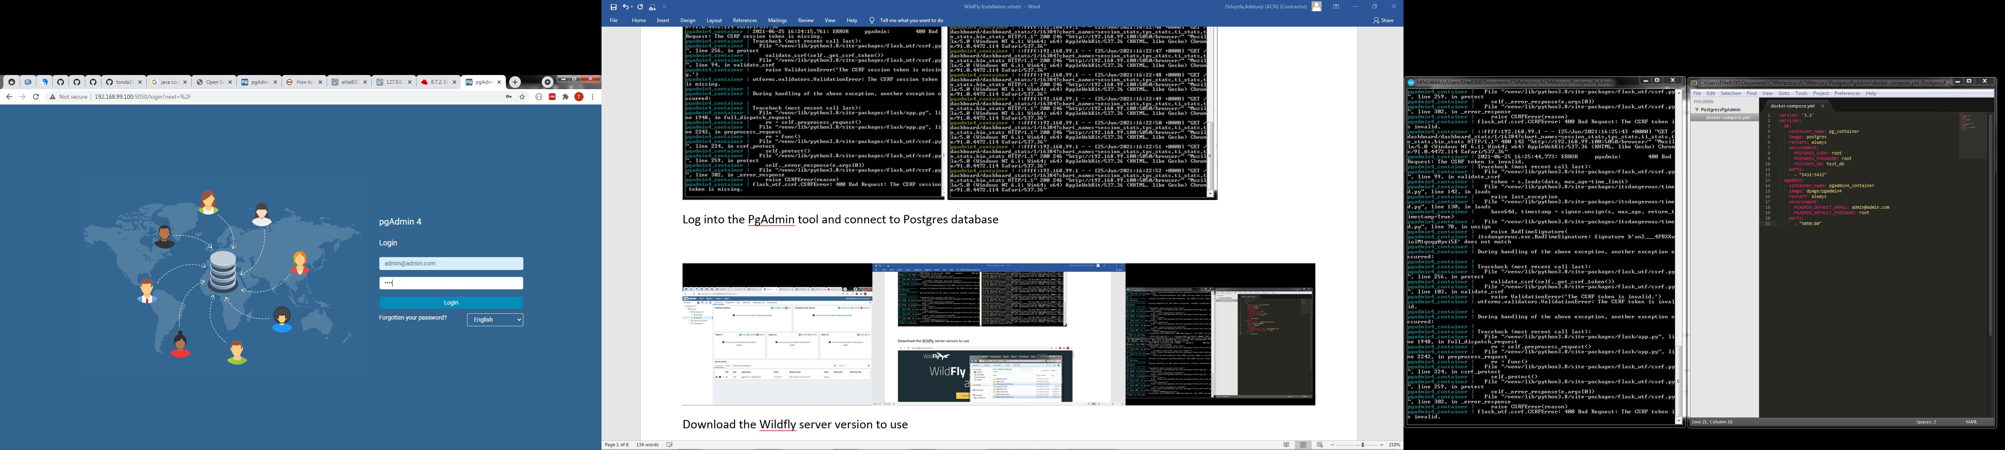

Connect to the Postgres database

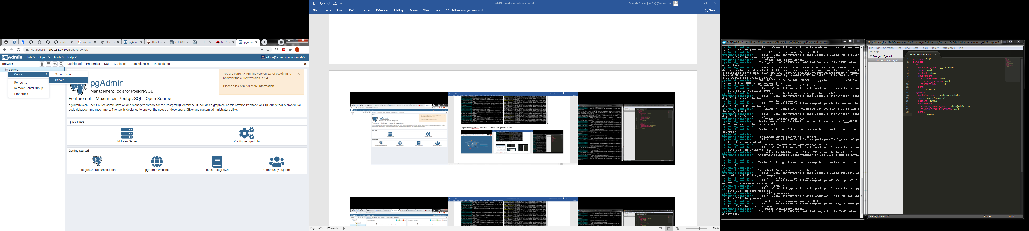

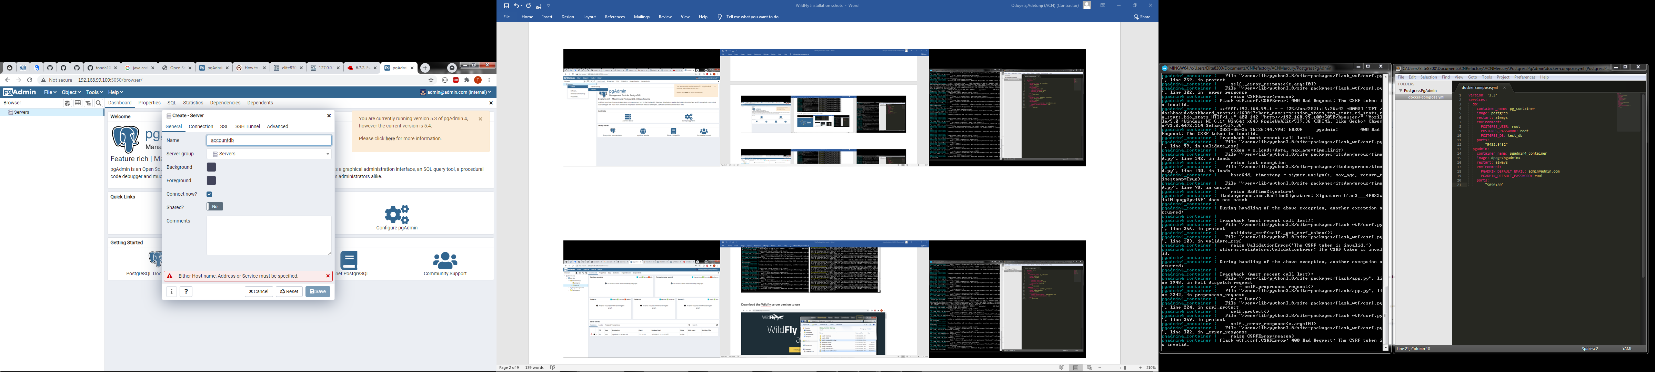

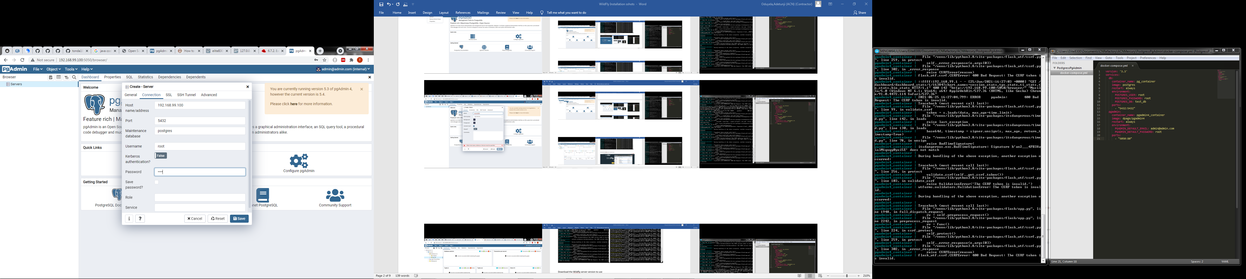

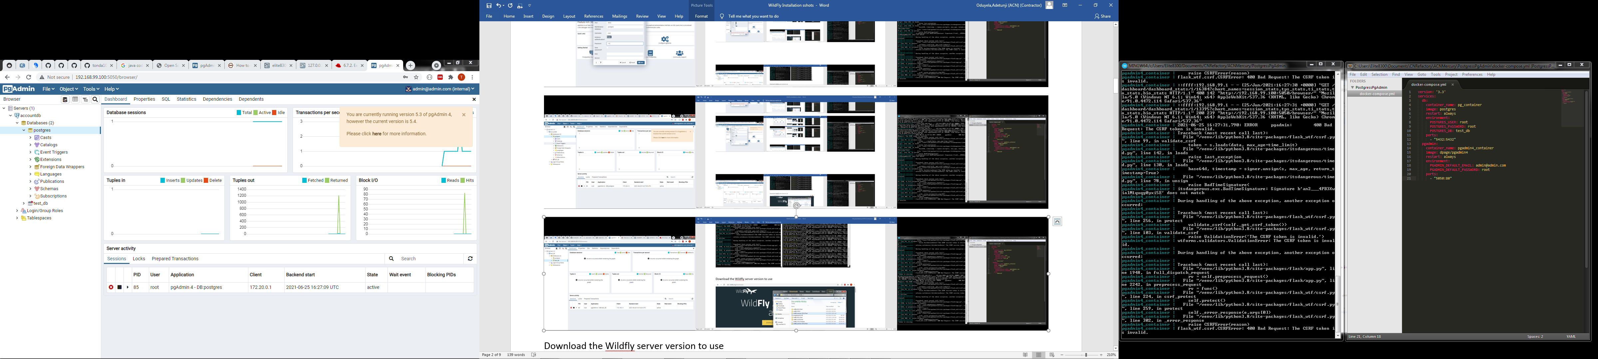

Next, download the Wildfly server version to use

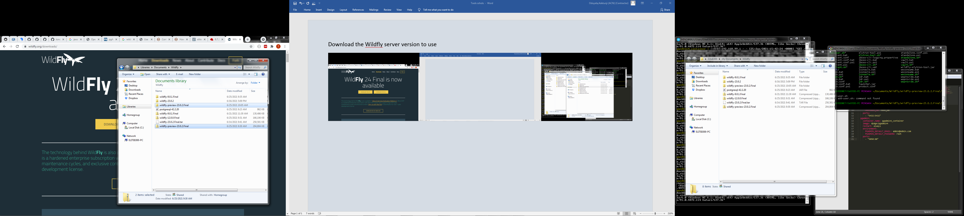

Add a user by running the add-user.sh file, add the user with username/password of **admin/admin1+**

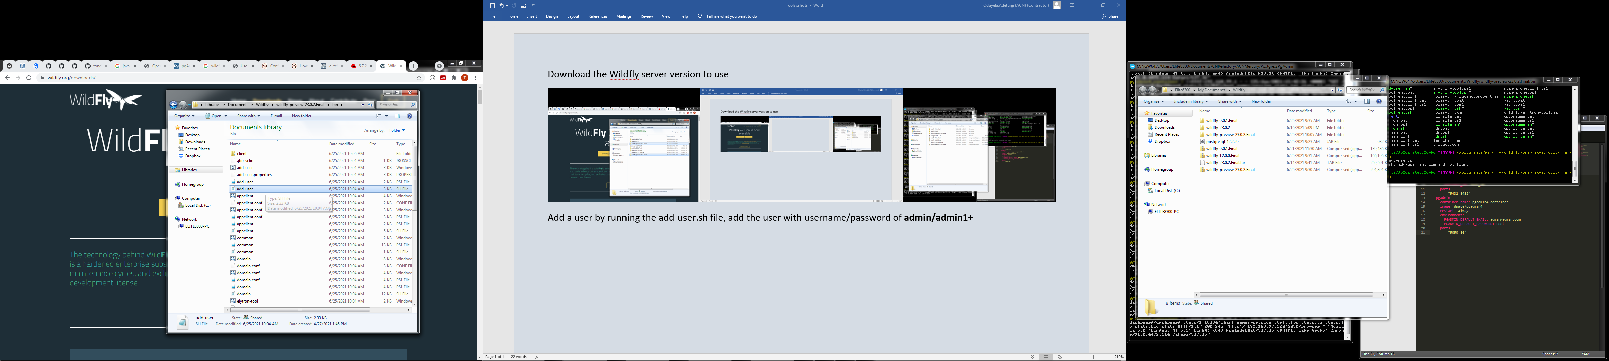

Run the Wildfly Server using the **standalone.sh** file within the bin folder

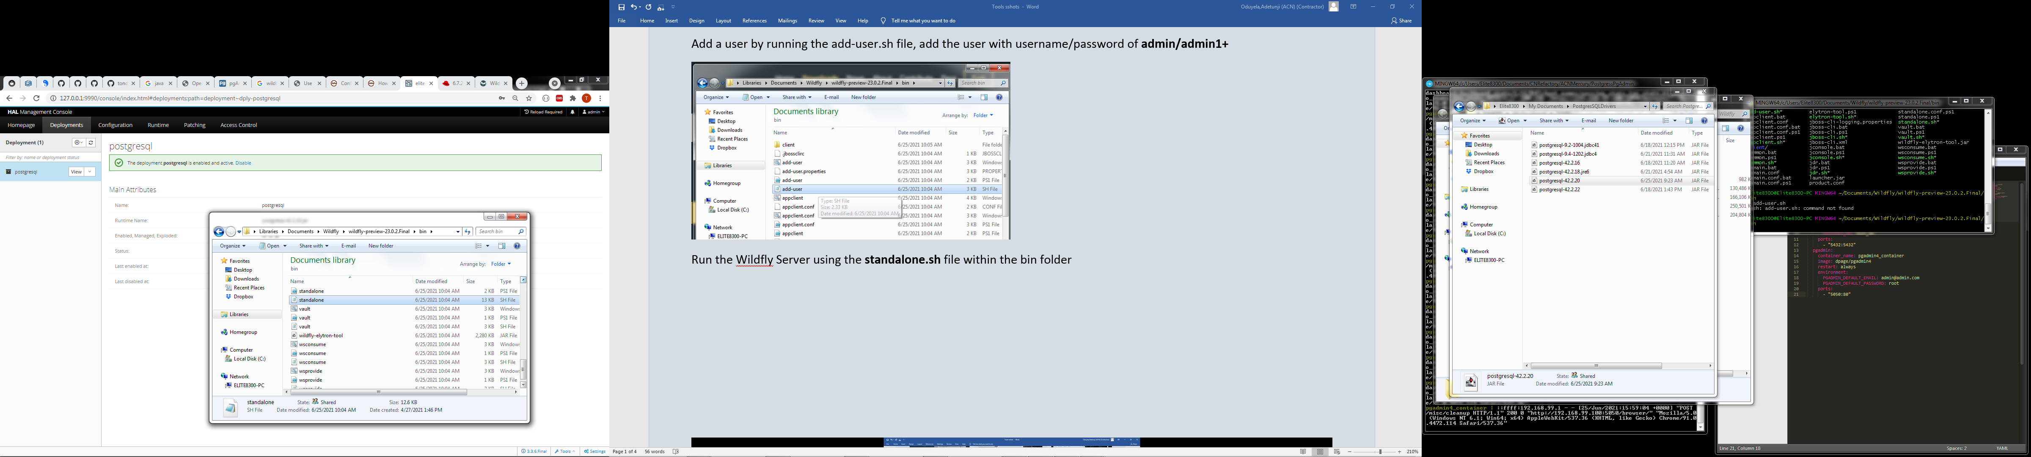

Download the PostgresSQL Driver .JAR file to use from <https://jdbc.postgresql.org/download.html>

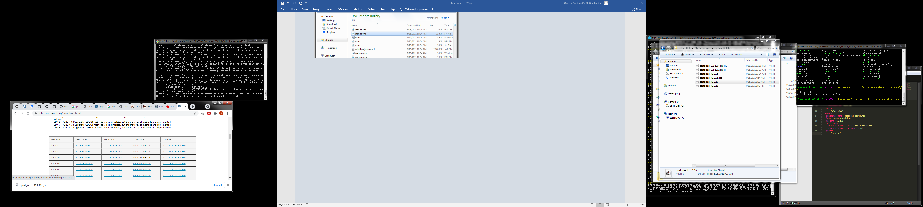

Upload the PostgresSQL Driver .JAR file into the Deployments section in Wildfly

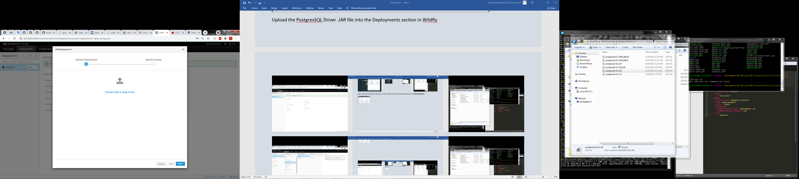

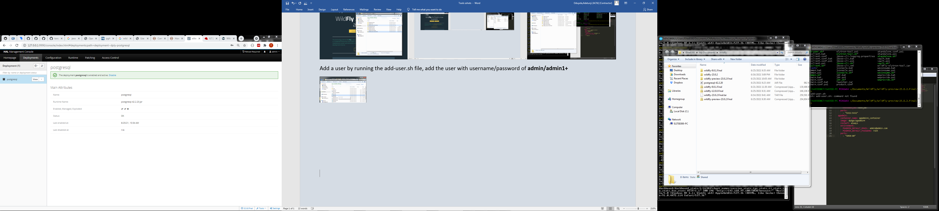

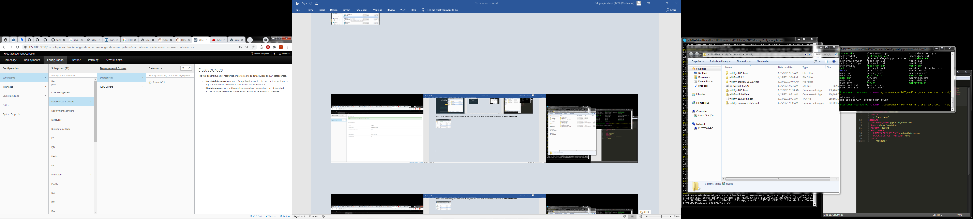

Add a new Datasource as below

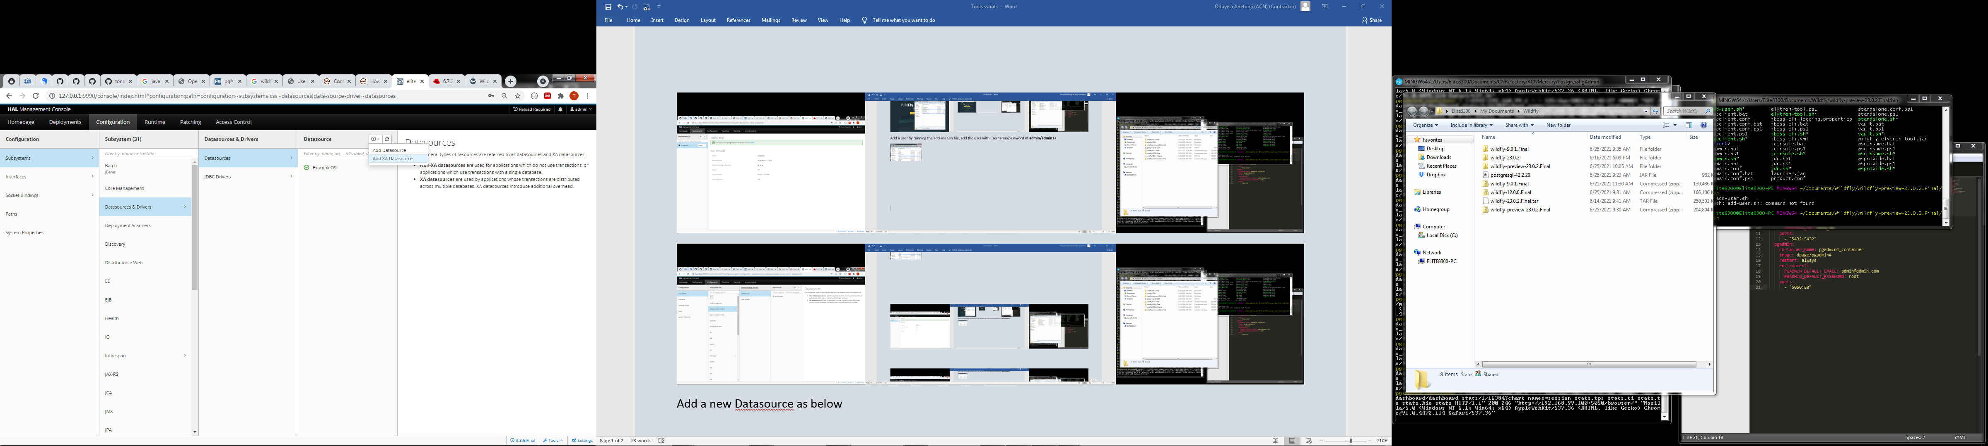

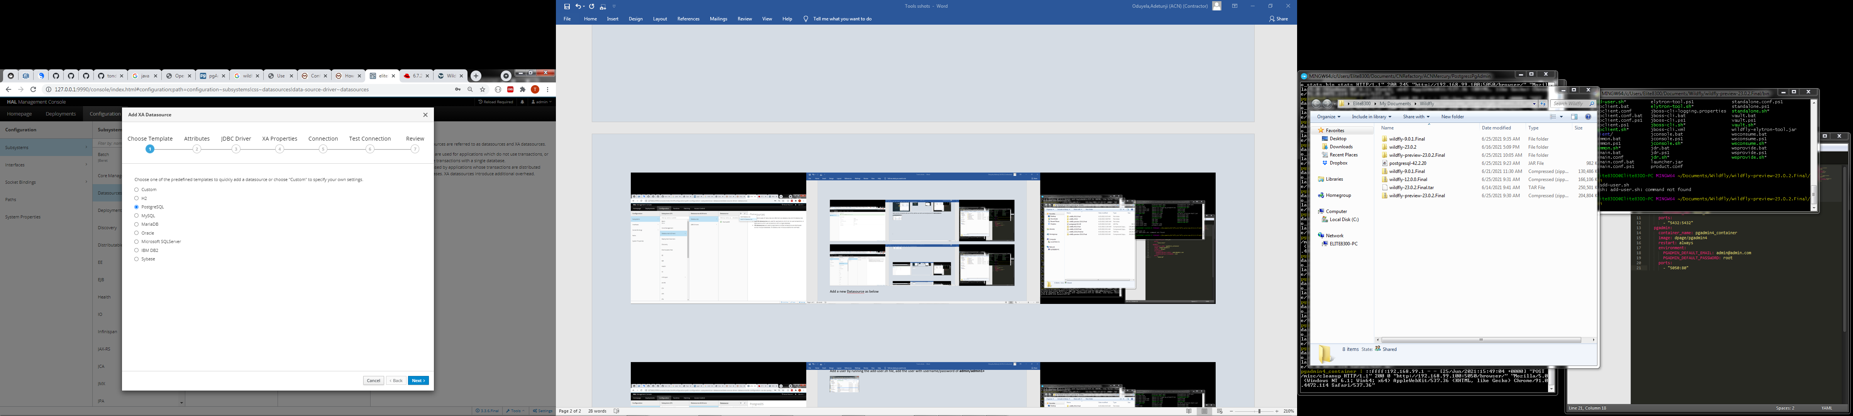

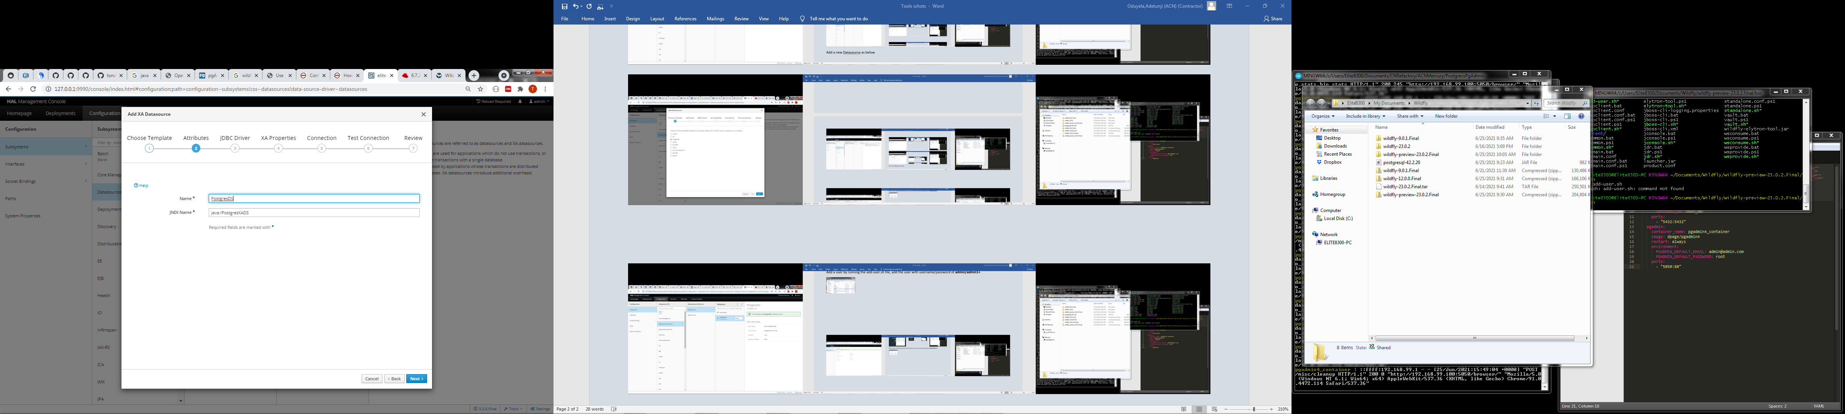

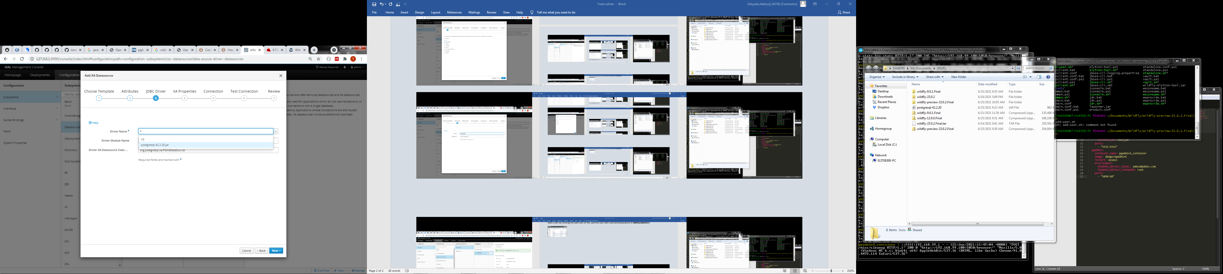

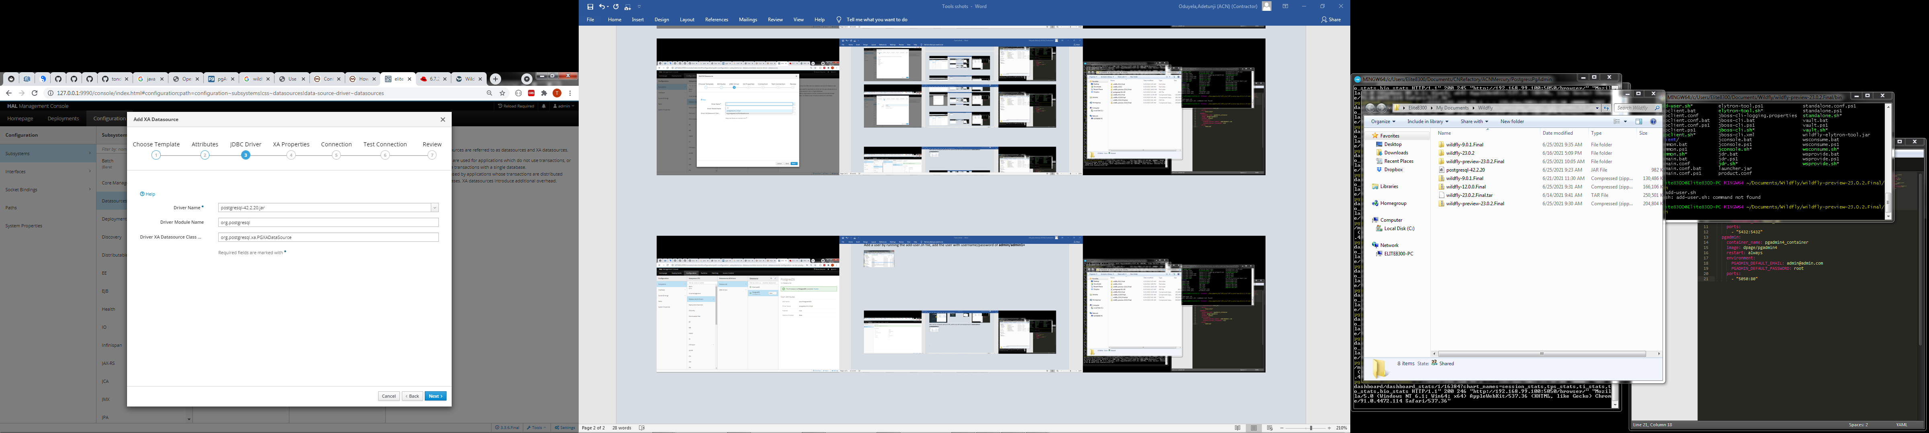

Add the XA Property values that identifies where your Postgres database is running **ServerName=192.168.99.100, PortNumber=5432, DatabaseName=postgresdb**

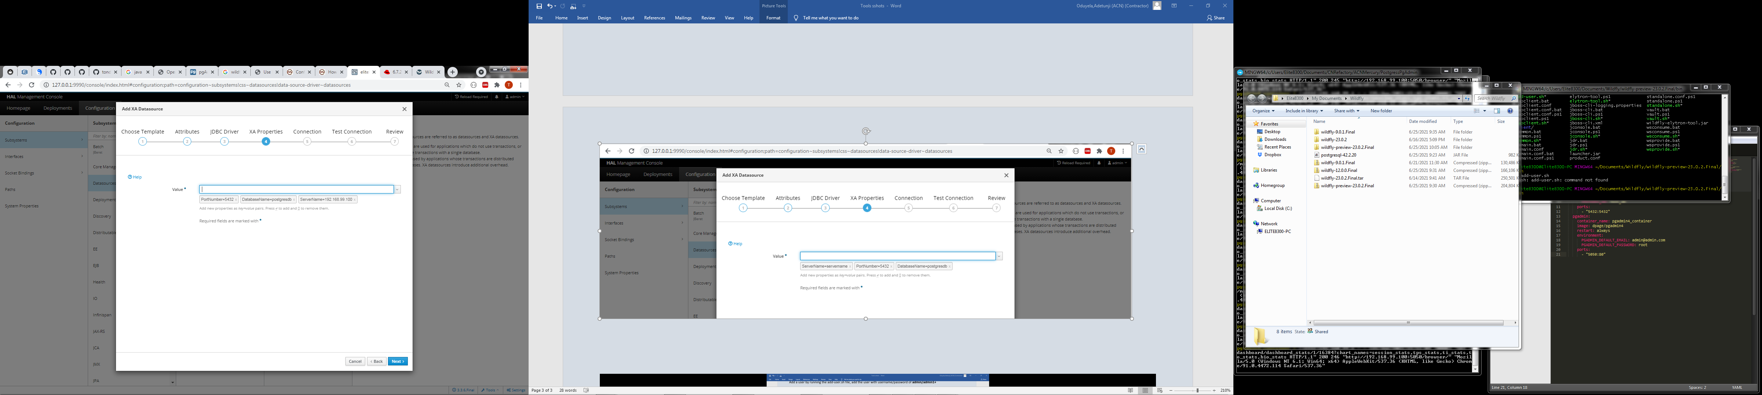

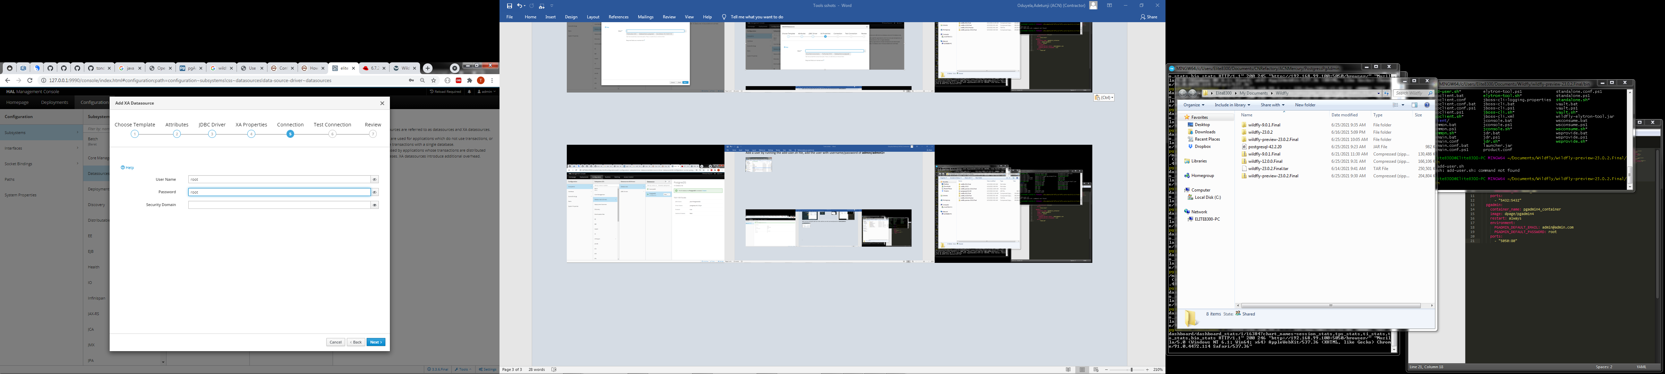

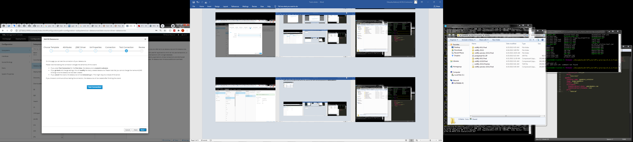

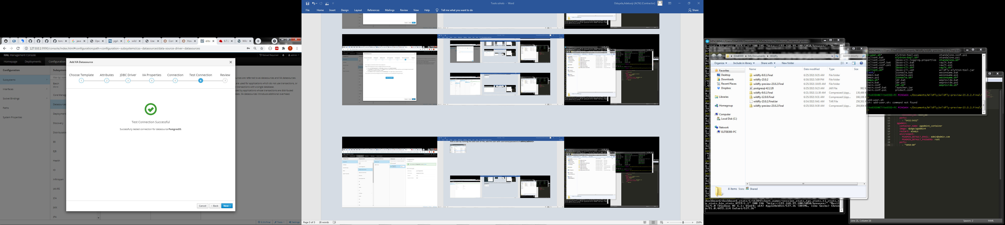

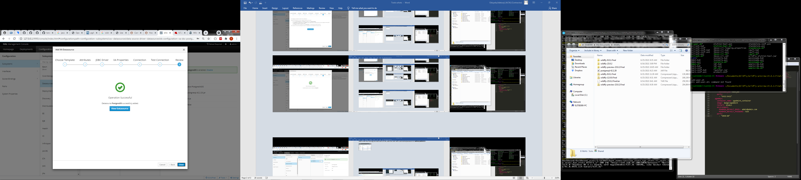

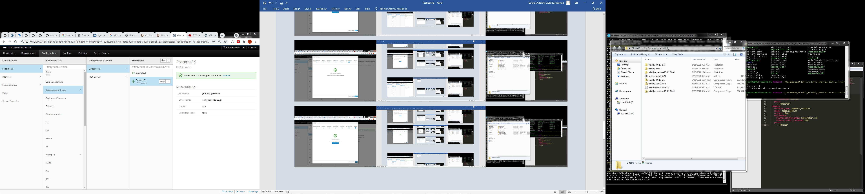

You now have the Postgres datasource connected and available for use.

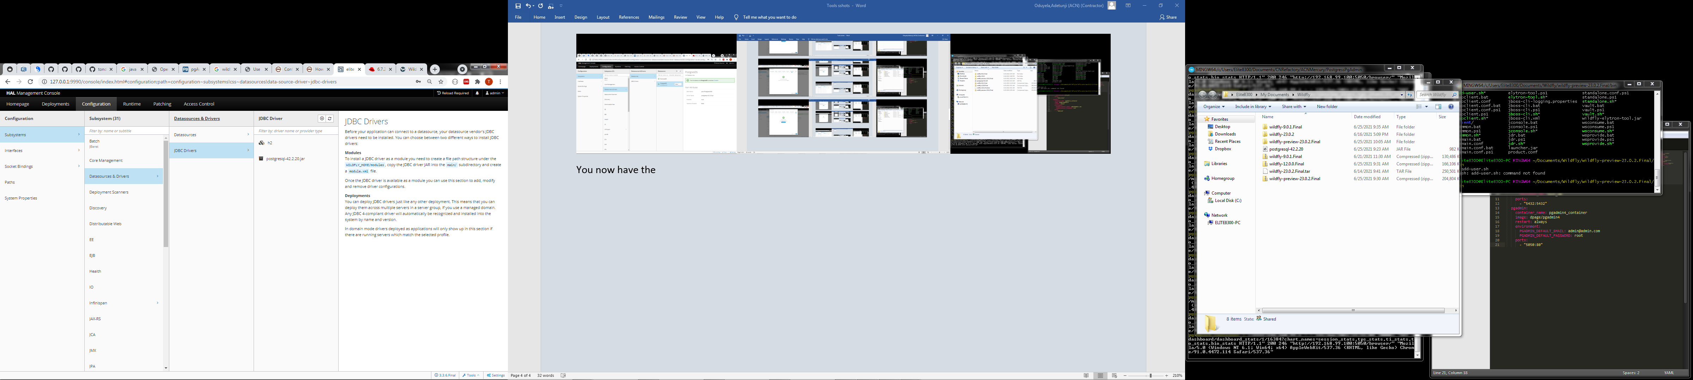

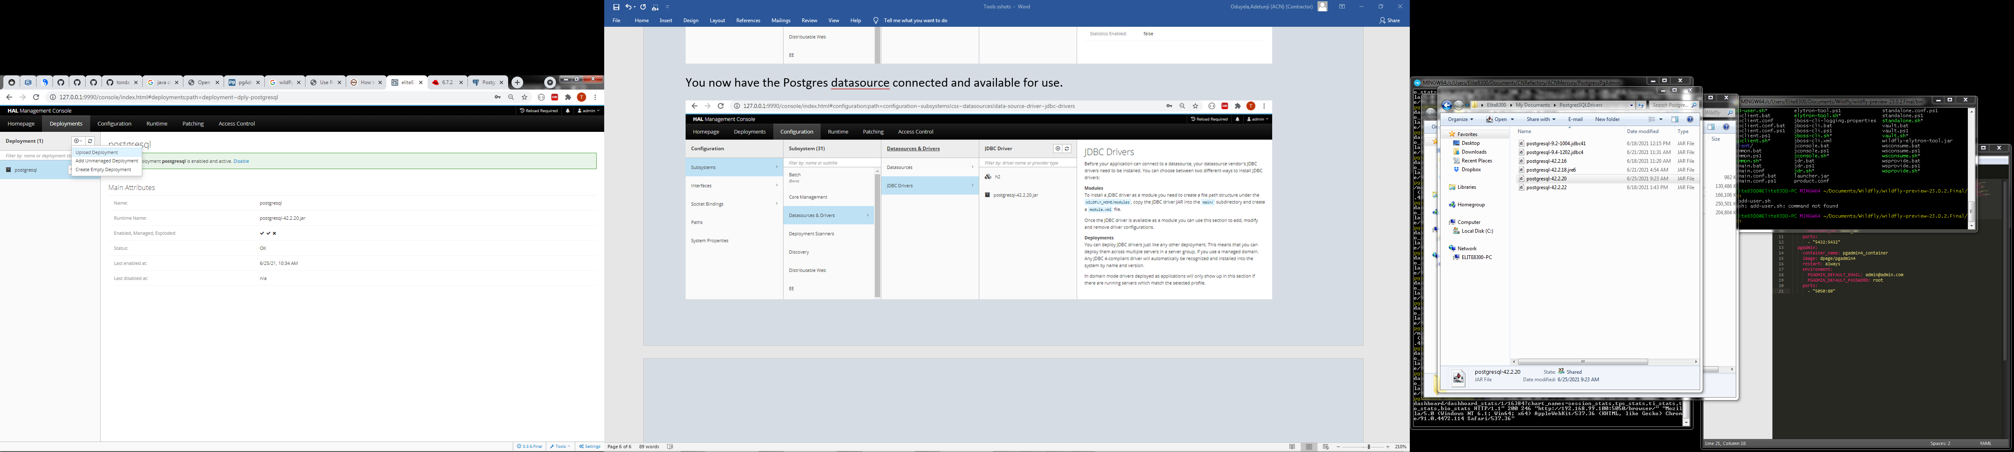

You can now upload your Legacy application .JAR or .WAR files using Postgres as database in the Deployment section.

